Competitive Edge Learning Center
Summer Camp 2022 Registration Packet

CELC Full-Day Summer Camps
The happiest place under Huntsville's summer sun! The Competitive Edge Learning Center has the best summer camp program that Huntsville has to offer. It is fun, safe, flexible, and affordable! CELC summer campers engage in activities all day, from reading, math, language arts, arts, and crafts to pickleball, field trips to 3D printing and drone technology. Our campers are never bored! Our low rates and flexible options are sure to keep you coming back for more! For all children ages 5-15
Dates:
Wednesday, June 1st -Friday, July 15th
Mon-Fri-7:30am – 4:00 pm
Costs: $99 Non-refundable deposit/per child
$12 per/T-Shirt
$165 per /week

Staying Home When Appropriate
• Employees and campers who are sick or have recently had close contact with a person
with COVID-19 must stay home, monitor their health, and call the director for further
instructions.
• Employees and campers should stay home if they have tested positive for or are showing
COVID-19 symptoms.
• We practice hand Hygiene and Respiratory Etiquette.
• We teach and reinforce handwashing with soap and water for at least 20 seconds and
increase monitoring to ensure adherence among campers and staff.
• If soap and water are not readily available, hand sanitizer that contains at least 60%
alcohol can be used (for staff and older children who can safely use hand sanitizer).
• We encourage staff and campers to cover coughs and sneezes with a tissue. Used tissues
should be thrown in the trash, and hands washed immediately with soap and water for at
least 20 seconds.
• If soap and water are not readily available, hand sanitizer that contains at least 60%
alcohol can be used (for staff and older campers who can safely use hand sanitizer).
Masks
• We teach and reinforce the use of masks. Masks should be
worn by staff and campers (particularly older campers) as feasible and are essential
in times when physical distancing is difficult. Information will be provided to staff and
campers on proper use, removal, and washing of masks.
• Masks offer some protection to the wearer and are also meant to protect those around
the wearer in case they are infected with the virus that causes COVID-19.
Adequate Supplies
• We ensure that every child has access to sinks and enough supplies for them to clean
their hands and cover their coughs and sneezes. Supplies include soap, a way to dry
hands (e.g., paper towels, hand dryer), tissues, hand sanitizer with at least 60 percent
alcohol (for staff and older campers who can safely use hand sanitizer), disinfectant
wipes, masks.
Information for Parents
General Information
Arrival between: 7:30-8:00  academic enrichment 8:15-10:45  Approx. lunch: 11:00-11:45  Afternoon activities:(pickleball, STEM, art,  basketball, swimming)12:00-3:30 | Follow up instructions and clean up: 3:30-4:00  Dismissal: 4:00

Field Trips:
Field trips will vary week to week based on the weather. On some field trips, we will be walking (i.e., OU gym, natatorium); on some occasions will be taking vans with their licensed drivers. Please ensure that each child is equipped with closed-toed tie shoes, a backpack, a water bottle, sunscreen, and anything else you feel they may need for all field trips. Students will be carrying their belongings, so keep it light! Specific information for each adventure will be given out a week prior.

How to Register
- Read Summer Camp Rules & Policies
- Fill out all required forms (registration, liability, scheduling)
- Email or bring in immunization forms (competitiveedge17@yahoo.com)
- Bring completed packet (documents, immunization records, etc.) and deposits to CELC front desk.
We require weekly payments of $165 on Monday before the student starts or $1,155 for the entire 6-weeks camp experience.
We take cash app, use my phone number (912-675-6909) or ($comlearn), Zelle, checks, and credit cards (3% convenience fee).15 % Sibling discounts are available.

Child/Children’s Name: ________________________, __________________,_____________________,________________________
Age: _____ ,_______,_____D.O.B. _/___/___;___/___/___
Parent email address:_________________________Phone:_______________ Alt. Email address:_____________________
Emergency phone: number________________________________________

Camp Prices
$12 T-Shirt fee
$100 non-refundable deposit/ per child (includes one tee shirt)
$165 per /week; lunch included
Sibling Discount: 15% for every child after the first.

Camp Rules & Policies
Food/ Drinks
Healthy vegetarian lunches will be provided; however, you can pack a lunch and two (2) snacks that do NOT require refrigeration or heating. If your child needs more food, we will provide it for them. THERE IS NO SHARING OF FOOD OR DRINKS. If a student has peanut products in their lunch, please notify the front desk staff at drop-off. It will be labeled with a colored band. All food and drinks will be consumed in the Learning Center, and sometimes on a field trip. All water bottles, lunch boxes, food containers, etc., should be labeled with your child's name and placed in a cubby at the front. CELC camp t-shirt should be worn every day. Tee shirts can be purchased for $12 from the learning center.
Field Trips
CELC camp t-shirt must be worn on every field trip. If a student does not have
a camp t-shirt before leaving for the scheduled field trip, another must be
purchased for $12. Tennis shoes or good walking shoes must be worn to the gym.
For specific field trips, students will be eating on-site and must therefore bring a
sack lunch.
Permission Forms: Many of the field trips require their own permission forms,
which will be handed out every Monday of each week and must be filled out for
the child to participate.
Misc.
• Because of COVID, 19 students will be signing themselves in & out at the
front desk, providing names and phone numbers each day.
• Students must wear a face-covering in class and should adhere to the CDC
guidelines and protocol.
• No refunds for absences or partial weeks due to weather or any other
unforeseeable event.
• No cell phones are allowed. If a student brings a cell phone, it must be kept
in the student's book bag until the end of the camp day. Any electronics that
are brought to the center are not the responsibility of the camp. Any losses or
damages will be the responsibility of the parent/ child. The CELC phone is
always available for use at (256) 489-2092 or (912)-675-6909 to contact
parents/ guardians and children.
• Shoes (closed-toed) must be worn to the center each day.
• CELC tee shirt should be worn every day unless specified. You must initial all statements and sign at the bottom of this section to participate in CELC Summer Camp.

____ I understand that the deposit I pay is non-refundable, with no exceptions.
____ I understand that if my child is absent or the center is closed because of a holiday or any other unforeseeable event, the weekly pay is not refunded, with no exceptions.
____ I understand that my camp balance is due the Monday morning of my camp week, or I will lose my child's spot.
____ I understand that if I am more than 10 minutes late for the 4:00 pick-up time. I will be charged $1.00 per minute, starting
____ I understand that my child must adhere to CELC's Safety Rules and Policies and that recurring transgressions may result in my child losing their spot in camp without a refund or permission to return.
Parent/ Guardian Signature ________________________________________ Date ___/___/___

Please list and describe any allergies and known medical conditions that CELC should be aware of.
______________________________________________________________________________________

Additional Pick-Up Release
I have authorized the following person(s) to pick up my child/ children from CELC's 2021 Summer camp.
Name: _____________________________
Name: _____________________________
Telephone: _________________________
Telephone: _________________________

____________________________Does NOT have authorization to pick up my child children.
Field Trips & Movies
All statements must be read and initialed; please sign at the bottom of this section to participate in CELC Summer Camp.

____ I understand that by dropping my child off on a day with off-site field trips, my child will be participating in some field trips, including but not limited to Oakwood University Natatorium and Gym.

____ I understand that my child/ children will be riding on a CELC Van to get to many of the scheduled field trip activities or walk as a group to the field trip destination.

____ I understand that my child/ children will participate in swimming activities. I consent to this arrangement and will notify the summer staff if this changes.
Parent/ Guardian Signature ______________________________________

Child Name: _______________________ Age: _____ D.O.B. ___/___/___

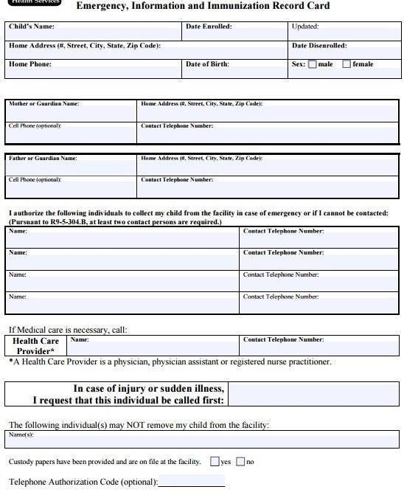
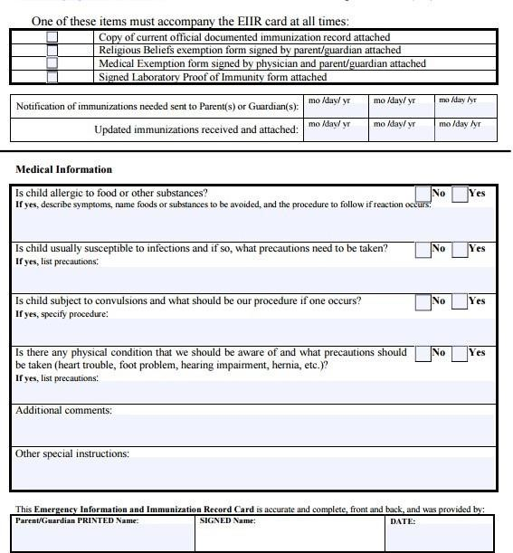

RELEASE OF LIABILITY
READ CAREFULLY - THIS AFFECTS YOUR LEGAL RIGHTS

In exchange for participation in the activity of Summer Camp organized by Competitive Edge Learning Center, of 5310 Millennium Drive, Huntsville, Alabama, 35806 and/or use of the property, facilities, and services of Competitive Edge Learning Center, I agree for myself and (if applicable) for the members of my family, to the following:

- AGREEMENT TO FOLLOW DIRECTIONS. I agree to observe and obey all posted rules and warnings and further agree to follow any oral instructions or directions given by Competitive Edge Learning Center or the employees, representatives, or Competitive Edge Learning Center agents.

- ASSUMPTION OF THE RISKS AND RELEASE. I recognize that there are certain
inherent risks associated with the above-described activity, and I assume full responsibility for personal injury to myself and (if applicable) my family members, and further release and discharge Competitive Edge Learning Center for injury, loss, or damage arising out of my or my family's use of or presence upon the facilities of Competitive Edge Learning Center, whether caused by the fault of myself, my family, Competitive Edge Learning Center or other third parties.

- INDEMNIFICATION. I agree to indemnify and defend Competitive Edge Learning Center against all claims, causes of action, damages, judgments, costs, or expenses, including attorney fees and other litigation costs, which may in any way arise from my or my family's use of or presence upon the facilities of Competitive Edge Learning Center.

- FEES. I agree to pay for all damages to the facilities of Competitive Edge Learning Center caused by any negligent, reckless, or willful actions by my family or me.

- CONSENT. I, _________________ of _________________, _________________,
_________________ _________________, consent to the participation of my
_________________, Minor Child, in the activity of Summer Camp, and agree on behalf of the above minor to all of the terms and conditions of this Agreement. By signing this Release of Liability, I represent that I have legal authority over and custody of Minor Child.
MEDICAL AUTHORIZATION. In the event of an injury to the above minor during the above-described activities, I give my permission to Competitive Edge Learning Center or the employees, representatives, or agents of Competitive Edge Learning Center to arrange for all necessary medical treatment. I shall be financially responsible. This temporary authority will begin on _________________ and will remain in effect until terminated in writing by the undersigned or when the above-described activities are completed. Competitive Edge Learning Center shall have the following powers:

a. The power to seek appropriate medical treatment or attention on behalf of my child as may be required by the circumstances, including without limitation, that of a licensed medical physician and/or a hospital.
b. The power to authorize medical treatment or medical procedures in an emergency; and\

c. The power to make appropriate decisions regarding clothing, bodily nourishment, and shelter.

- APPLICABLE LAW. Any legal or equitable claim that may arise from participation in the above shall be resolved under Alabama law.

7.NO DURESS. I agree and acknowledge that I am under no pressure or duress to sign this Agreement and that I have been given a reasonable opportunity to review it before signing. I further agree and acknowledge that I am free to have my legal counsel review this Agreement if I so desire. I further agree and believe that Competitive Edge Learning Center has offered to refund any fees I have paid to use its facilities if I choose not to sign this Agreement.

8. ARM'S LENGTH AGREEMENT. This Agreement and its terms are the product of an arm's length negotiation between the Parties. In the event an ambiguity exists in interpreting this Agreement or any of its provisions, the Parties. Each of them explicitly rejects applying any legal or equitable rule of interpretation which would lead to construction either "for" or "against" a particular party based upon their status as the drafter of a specific term, language, or provision giving rise to such ambiguity.

9.ENFORCEABILITY. The invalidity or unenforceability of any provision of this
The Agreement, whether standing alone or as applied to a particular occurrence or circumstance, shall not affect the validity or enforceability of any other provision of this Agreement or any other applications of such provision and such invalid or unenforceable provision shall be deemed not to be a part of this Agreement.

10.DISPUTE RESOLUTION. The parties will attempt to resolve any dispute arising out of or relating to this Agreement through friendly negotiations amongst the parties. If the matter is not determined by negotiation, the parties will resolve the dispute using the below Alternative Dispute Resolution (ADR) procedure.

Any controversies or disputes arising out of or relating to this Agreement will be submitted to mediation following any statutory rules of mediation. Suppose mediation is not successful in resolving the entire dispute or is unavailable. In that case, any outstanding issues will be submitted to final and binding arbitration under the American Arbitration Association rules. The arbitrator's award will be final, and judgment may be entered upon by any court with proper jurisdiction.

EMERGENCY CONTACT. In case of an emergency, please call _________________ (Relationship: _________________) at _________________ (Day), or _________________ (Evening).

I HAVE READ THIS DOCUMENT AND UNDERSTAND IT. I FURTHER
UNDERSTAND THAT BY SIGNING THIS RELEASE, I VOLUNTARILY SURRENDER CERTAIN LEGAL RIGHTS.
This Release of Liability is executed and agreed to by:
Parent/ Guardian signature: ___________________________________________

Immunizations/ Emergency Forms

Immunizations are a significant public health policy affecting children. As a matter of state law, children in the program must:
- Be fully immunized.
- Be in the process of becoming fully vaccinated according to the approved schedule or,
- Have a physician's statement that immunizations are not needed for medical reasons or a note from the parent stating that the child is not immunized due to religious beliefs. The immunization form must be completed and turned in with the registration packet before the start of camp.
Please have your physician send or email immunization records to
Competitive Edge Learning center @ competitiveedge17@yahoo.com
(256) 945-5265 or (912) 675-6909

Camp Packet Checklist
- Completed Registration Form
- Completed Immunization Form (faxed OK)
- Completed Liability Form
- Completed Travel Permission Form
- Completed Emergency Contact
- Information Sheet
- Registration Fee Paid, t-shirt distributed.
- Entered System

