Competitive Edge Learning Center
Summer Camp 2019 Registration Packet

CELC Full-Day Summer Camps

The happiest place under Huntsville’s summer sun! Competitive Edge Learning Center has the best summer camp program that Huntsville’s has to offer. It’s fun, flexible, and affordable! CELC summer campers engage in themed activities all day, every day; from Art to Basketball, field trips to Robotics and Drone technology, our campers are never bored! Our low rates and flexible options are sure to keep you coming back for more!

For all children ages 4-14
Dates:
Tuesday May 28th -Friday July 19th
7:30am – 5:30 pm

Costs:
$10 T-Shirt fee
$45 non-refundable deposit/ per child
$140 per /week

Information for Parents

General Information  Snack Times: 9 am & 3 pm  Approx. Lunch: 12:00 noon | Quiet Time  Snack Times: 9 am & 3 pm  Approx. Lunch: 12:00 noon

Field Trips:

Field trips will vary week to week, based on the theme. Some field trips we will be walking (i.e. OU gym, natatorium), others we will be taking vans with their licensed drivers. For all field trips, please make sure that each child is equipped with closed-toed, tie shoes, a backpack, water bottle, sun screen, and anything else you feel they may need. Students will be carrying their belongings so keep it light! Specific information for each adventure will be given out a week prior.

How to Register

1. Read Summer Camp Rules & Policies
2. Fill out all required forms (registration, liability, scheduling)
3. Email or bring in immunization forms (competitiveedge17@yahoo.com)
4. Bring completed packet (forms, immunization records, etc.) and
deposits to CELC front desk.

Camp Rules & Policies

Food/ Drinks

Healthy vegetarian lunches will be provided; however, you can pack a lunch and two (2) snacks that do NOT require refrigeration or heating. If your child needs more food, we will provide it for them. THERE IS ABSOLUTELY NO SHARING OF FOOD OR DRINKS. If a student has peanut products in their lunch, please notify the front desk staff at drop-off so that the lunch box may be labeled with a colored band. All food and drinks will be consumed in the Learning Center only. All water bottles, lunch boxes, food containers, etc. should be labeled with your child’s name and placed in a cubby at the front.

Field Trips

CELC camp t-shirts must be worn on Mondays, Wednesdays, and Fridays. If a student does not have a camp t-shirt before we leave for the scheduled field trip, another must be purchased for $10. Tennis shoes or good walking shoes must be worn to the gym. For certain field trips students will be eating on-site and must therefore bring a sack lunch.

Permission Forms: Many of the field trips require their own permission forms, which will be handed out every Monday of each week and must be filled out for the child to participate.
Misc.
• Parents/ Guardians must sign each child in & out at the front desk, providing names and phone numbers each day.
• No cell phones are allowed. If a student brings a cell phone it must be kept in the student’s bookbag until the end of the camp day. Any electronics that are brought to the center are not the responsibility of the camp, any losses or damages will be the responsibility of the parent/ child. The CELC phone is always available for use (256) 945-5265 to contact parents/ guardians and children.
  - • Shoes (closed toed) must be worn to the gym each day.
  - • Please check the lost and found box at the end of each week. All items left at the end of summer will be donated!

Payment Policies
You must initial all statements and sign at the bottom of this section to participate in CELC Summer Camp.

____ I understand that the deposit I pay is non-refundable with no exceptions. It may, however be transferred to
another week of camp.
____ I understand that my camp balance is due the Monday morning of my camp week, or I will lose my child’s spot.
____ I understand that if I am more than 10 minutes late for the 5:30 pick-up time.
I will be charged $1.00 per minute, starting at 5:40 pm.
____ I understand that my child must adhere to CELC’s Safety Rules and Policies,
and that recurring transgressions may result in my child losing their spot in camp
without refund or permission to return.

Parent/ Guardian Signature ________________________________________ Date ___/___/___
Allergies & Medical Conditions
Please list and describe any allergies and known medical conditions that CELC should be aware of. _____________________________________________________________________________________________________________________________________________________________________________________________________________________________________________________________________________________________________________________________________________________________________________
Additional Pick-Up Release
I have authorized the following person(s) to pick up my child/ children from CELC’s 2019 Summer camp.
Name: _____________________________
Name: _____________________________
Telephone: ________________________
Telephone: ________________________

____________________________Does NOT have authorization to pick up my child children.
Field Trips & Movies
All statements must be read and initialed, please sign the bottom of this section to participate in CELC Summer Camp.

____ I understand that by dropping my child off on a day with off-site field trips, my child will be participating in
some field trips including but not limited to Oakwood University Natatorium and Gym.

____ I understand that my child/ children will be riding on an CELC Van to get to many of the scheduled
field trip activities or else walking as a group to the field trip destination.

____ I understand that my child/ children will watch a movie rated “G” or “PG” most Fridays, I consent to this arrangement
and will notify the summer staff if this change.
Parent/ Guardian Signature ______________________________________

CELC 2019 Summer Camp Registration Form

Child Name: _______________________ Age: _____ D.O.B. ___/___/___

Child Name: ________________________Age: _____ D.O.B. ___/___/___

Child Name: ________________________ Age: _____ D.O.B. ___/___/___

Camp Prices

$10 T-Shirt fee
$45 non-refundable deposit/ per child (family discounts available)
$140 per /week

Sibling Discount: 15% for every child after the first.

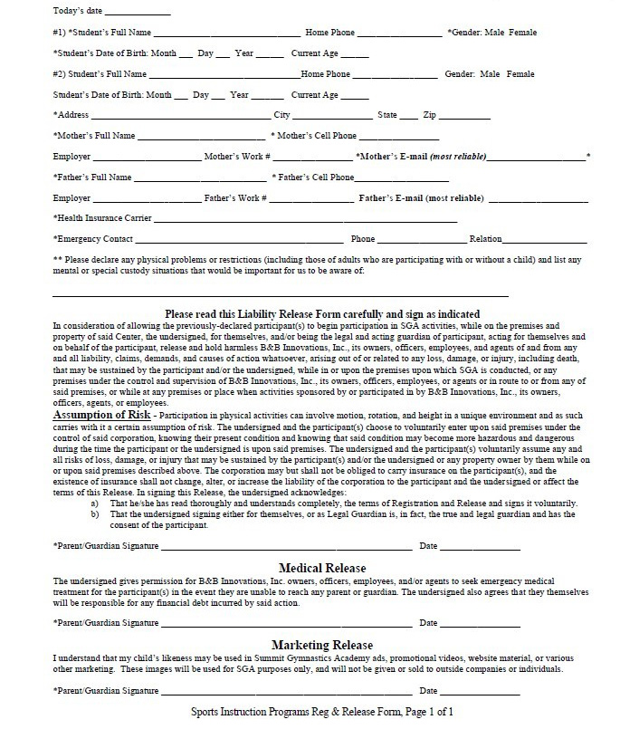
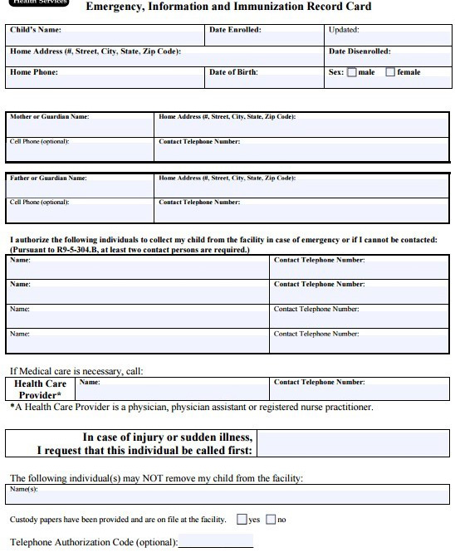
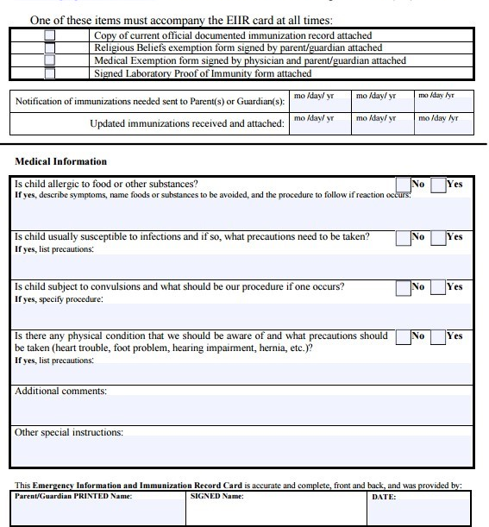

Immunizations/ Emergency Forms

Immunizations are an important public health policy affecting children. As a matter of state law, children in the program must:
Be fully immunized
- Be in the process of becoming fully immunized according to the approved schedule or,
- Have a physician’s statement that immunizations are not needed for medical reasons or a note from the parent stating that the child is not immunized due to religious beliefs.
The immunization form must be completed and turned in with the registration packet before the start of camp.

Please have your physician send or email immunization records to Competitive Edge Learning center @ competitiveedge17@yahoo.com
(256) 945-5265

Camp Packet Checklist
- Completed Registration Form
- Completed Immunization Form (faxed OK)
- Completed Liability Form
- Completed Travel Permission Form
- Completed Emergency Contact Information Sheet
- Registration Fee Paid, t-shirt distributed
- Entered into System

